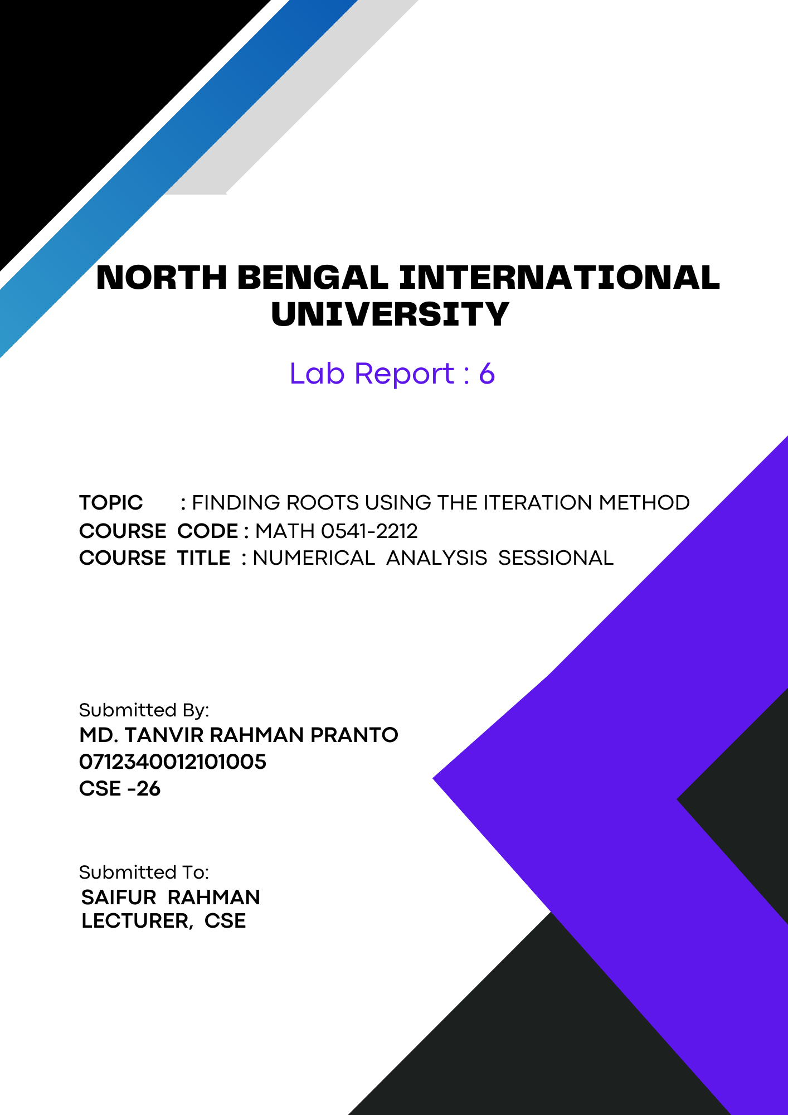
1

Finding Roots Using the Iteration Method:

Theory:
The Iteration Method, also known as Fixed Point Iteration, is a numerical technique used to find the roots of an equation. The basic idea is to transform the original equation into a form where the root can be approximated through successive iterations.
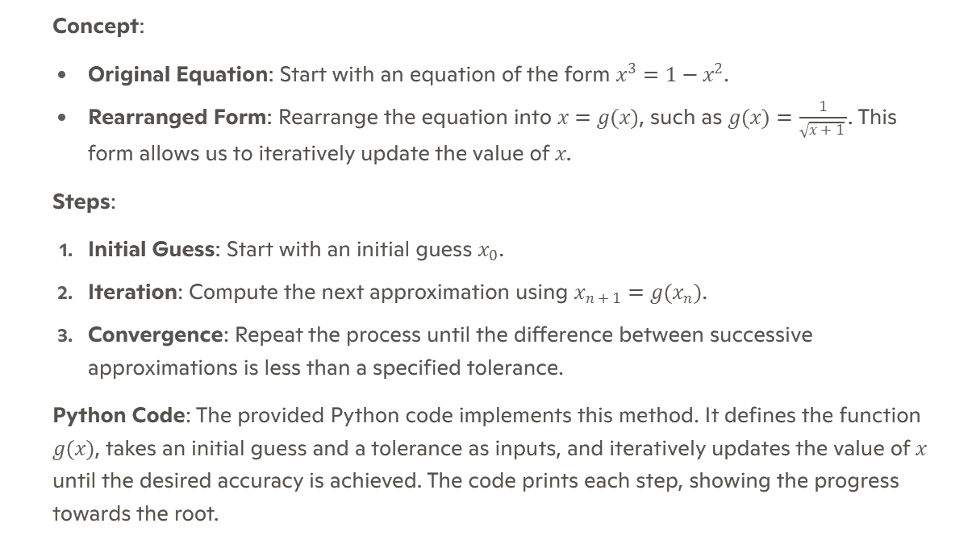

Algorithm:
Algorithm for Finding Roots Using the Iteration Method

1. Start

2. Import the math module
- Import the math module to use the square root function.

3. Define the function for iteration
- Define the function `f(x)` which is the rearranged form of the original equation for iteration:
f(x) = 1 / sqrt(x + 1)

4. Initialize variables
- Set the initial guess `x0` to 0.
- Set the tolerance `tolerance` to 10^-4.
- Initialize the iteration counter `i` to 1.
5. Compute the first iteration
- Calculate `x = f(x0)`.
- Print the current step and value of `x`.

6. Iterative process
- While the absolute difference between the new and previous values (`|x - x0|`) is greater than the tolerance:
- Increment the iteration counter `i`.
- Update `x0` to the current value of `x`.
- Compute the new value of `x` as `x = f(x0)`.
- Print the current step and value of `x`.

7. Output the final result
- Print the final value of `x` when the tolerance condition is met.

8. End

Code:
import math

# Given function x^3 = 1 - x^2 rearranged as
# f(x) = 1 / sqrt(x + 1) for iteration
def f(x):
return 1 / math.sqrt(x + 1)

# First approximation
x0 = 0

# Tolerance
tolerance = 10 ** -4

# Iteration count
i = 1

# Initial iteration
x = f(x0)
print(f"x{i} = {x:.6f}")

# Iterative process
while abs(x - x0) >= tolerance:
i += 1
x0 = x
x = f(x0)
print(f"x{i} = {x:.6f}")

print(f"Final x{i} = {x:.6f}")

Output:
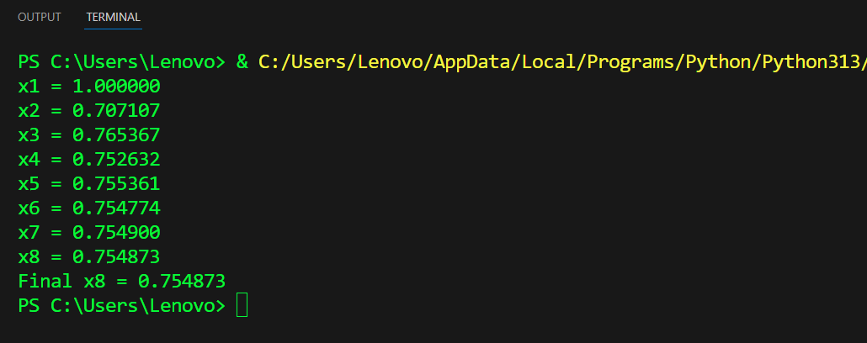

Conclusion: This Python code uses the Iteration Method to find the root of an equation. It iteratively updates the value of (x) using a transformed function until the difference between successive approximations is within a specified tolerance. The code's simplicity makes it an excellent tool for understanding numerical root-finding techniques.

